PSP0201

Week 4

Writeup

Group Name: GLM

Members

|  |  |  |
| --- | --- | --- |
| **ID** | **Name** | **Role** |
| 1211102971 | Leong Chun Kit | Leader |
| 1211103023 | Yap Weng Hong | Member |
| 1211101232 | Lim Kai Qian | Member |
| 1211101407 | Tan Fu Shun | Member |

**Day 11: Networking - The Rogue Gnome**

**Tools used**: Attack box

**Solution/walkthrough**:

Question 1

Vertical Privilege Escalation attack involves exploiting a vulnerability that allows you to perform action like commands or accessing data acting like high privilege account such as administrator.



Question 2

As I gained a foothold into the server into the server via www-data account. I managed to pivot it to another account that can run sudo commands. This kind of privilege escalation is vertical because sudo allow us to execute something with the permission as the most privileged user which can run sudo commands.





Question 3

horizontal privilege escalation attack involves using the intended permissions of a user to abuse a vulnerability to access another user's resources who has similar permissions.

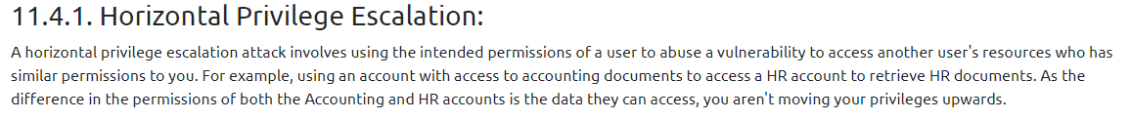

Question 4

We can use sudoers to help identify valuable users to us.

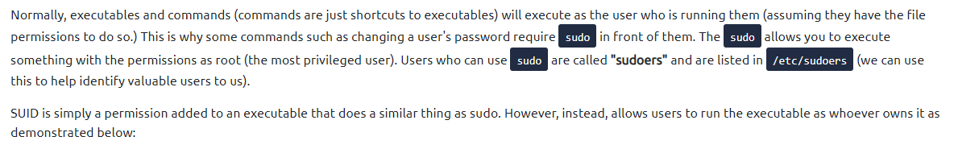

Question 5

The Linux command to enumerate the key for SSH is find / -name id_rsa 2> /dev/null which we use find to search volume by specifying the root / to search for files named id_rsa which is the name for private SSH keys and then using 2> /dev/null to only show matches to us.

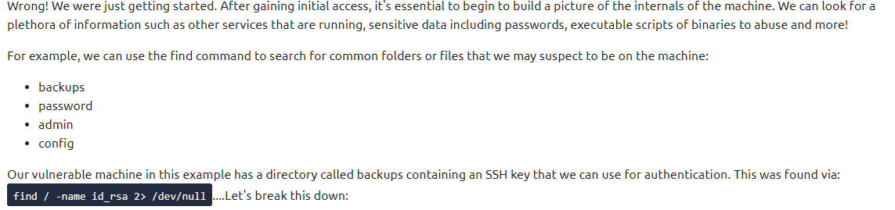



Question 6

If we need to add the execution permission to find.sh, we need this command which is chmod +x find.sh which make it able to execute.



Question 7

As we want use to host a http server using python 3 on port 9999, we should change the 8080 to 9999.



Question 8

As we use this executable to launch system shell as root, the contents of the file located at /root/flag.txt is this.

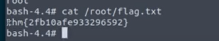

**Thought Process/Methodology:**

First, Vertical Privilege Escalation attack involves exploiting a vulnerability that allows you to perform action like commands or accessing data acting like high privilege account such as administrator. As I gained a foothold into the server into the server via www-data account. I managed to pivot it to another account that can run sudo commands. This kind of privilege escalation is vertical because sudo allow us to execute something with the permission as the most privileged user which can run sudo commands. Horizontal privilege escalation attack involves using the intended permissions of a user to abuse a vulnerability to access another user's resources who has similar permissions. Next, we can use sudoers to help identify valuable users to us. The Linux command to enumerate the key for SSH is find / -name id_rsa 2> /dev/null which we use find to search volume by specifying the root / to search for files named id_rsa which is the name for private SSH keys and then using 2> /dev/null to only show matches to us. If we need to add the execution permission to find.sh, we need this command which is chmod +x find.sh which make it able to execute. As we want use to host a http server using python 3 on port 9999, we should change the 8080 to 9999. As we use this executable to launch system shell as root, the contents of the file located at /root/flag.txt is this.

**Day 12: Networking - Ready, set, elf.**

**Tools used**: Attack box

**Solution/walkthrough**:

Question 1

As start, we type these commands and start scanning and wait awhile. After that we found the http-title which actually is the version number of the web server.

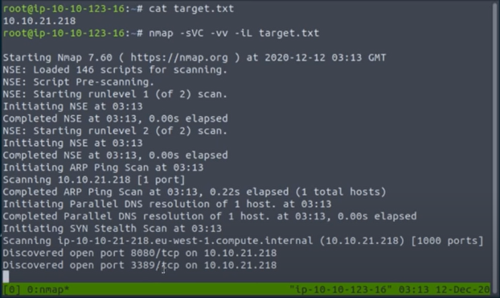

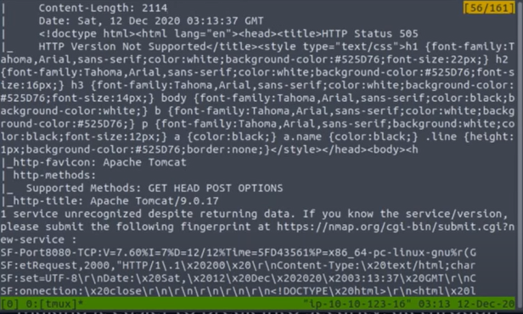

Question 2

We search the IP and copy to firefox. Then search the metasploit payload for "Apache Tomcat 9.0" CGI" .  Then we found the CVE.



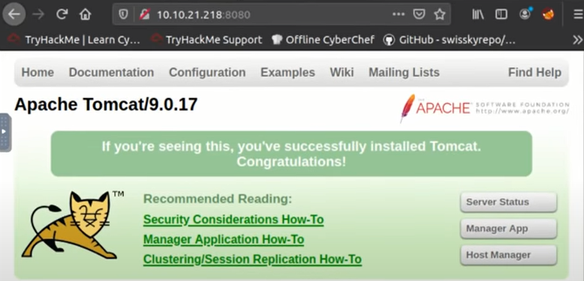

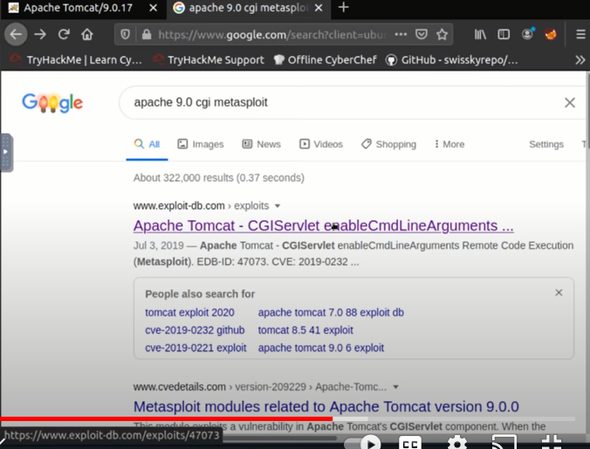

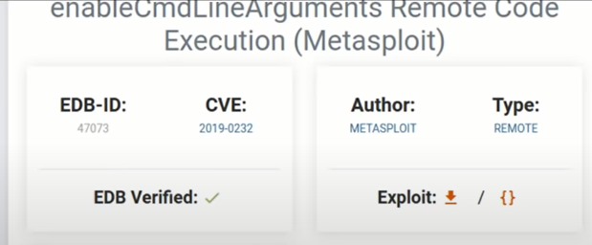

Question 3

We go type flag1.txt then we found the answer.

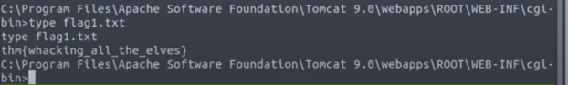

Question 4

The Metasploit settings we had to set is here.

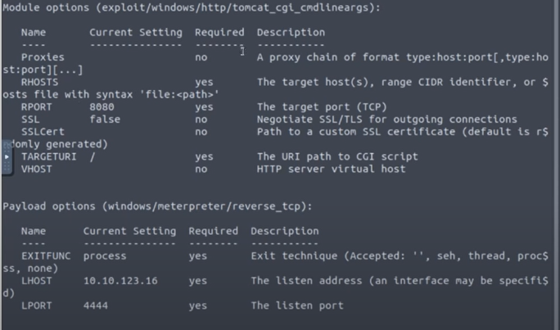

**Thought Process/Methodology:**

As start, we type these commands and start scanning and wait awhile. After that we found the http-title which actually is the version number of the web server. Next, we search the IP and copy to firefox. Then search the metasploit payload for "Apache Tomcat 9.0" CGI" .  Then we found the CVE. Then, we go type flag1.txt then we found the answer. The Metasploit settings we had to set is done.

**Day 13: Networking - Coal for Christmas**

**Tools used**: Attack box

**Solution/walkthrough**:

Question 1

Telnet was developed in 1969 and it provided access to a command-line interface on a remote host.

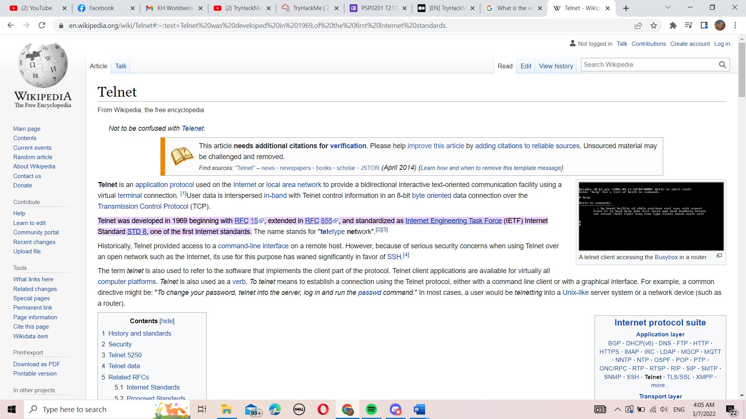

Question 2

Try login into the machine using telnet 10.10.185.12 on port 23

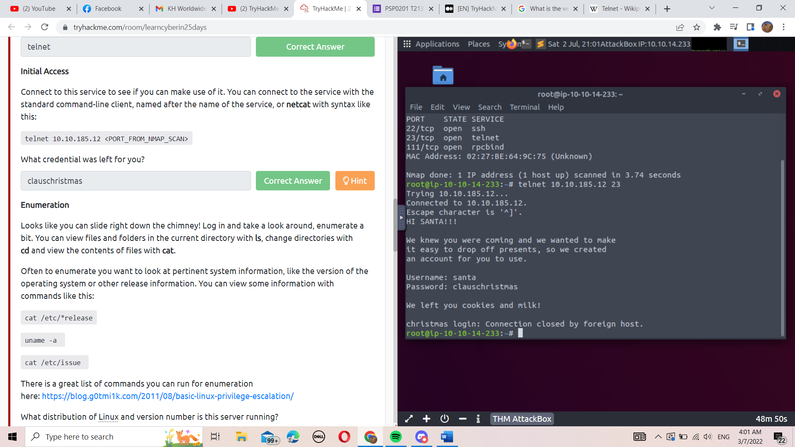

Question 3

Commanding cat /etc/*release and it will show the distribution of Linux and version number

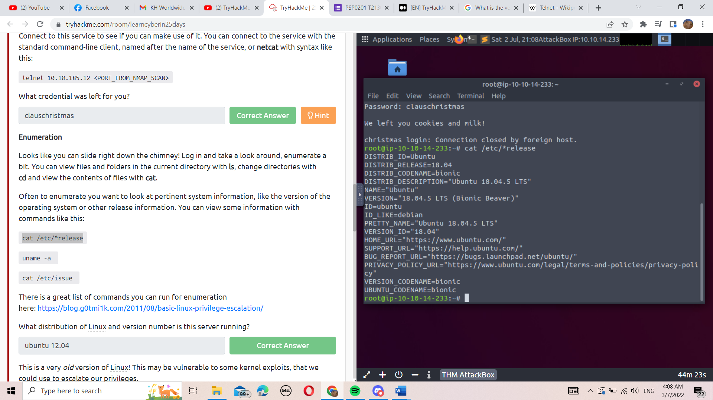

Question 4

Log in with the username and password given and do this with the cat command

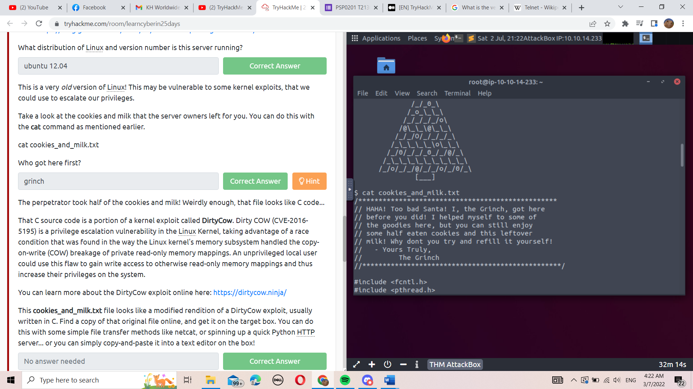

Question 5

We can see that the verbatim syntax you can use to compile in Github

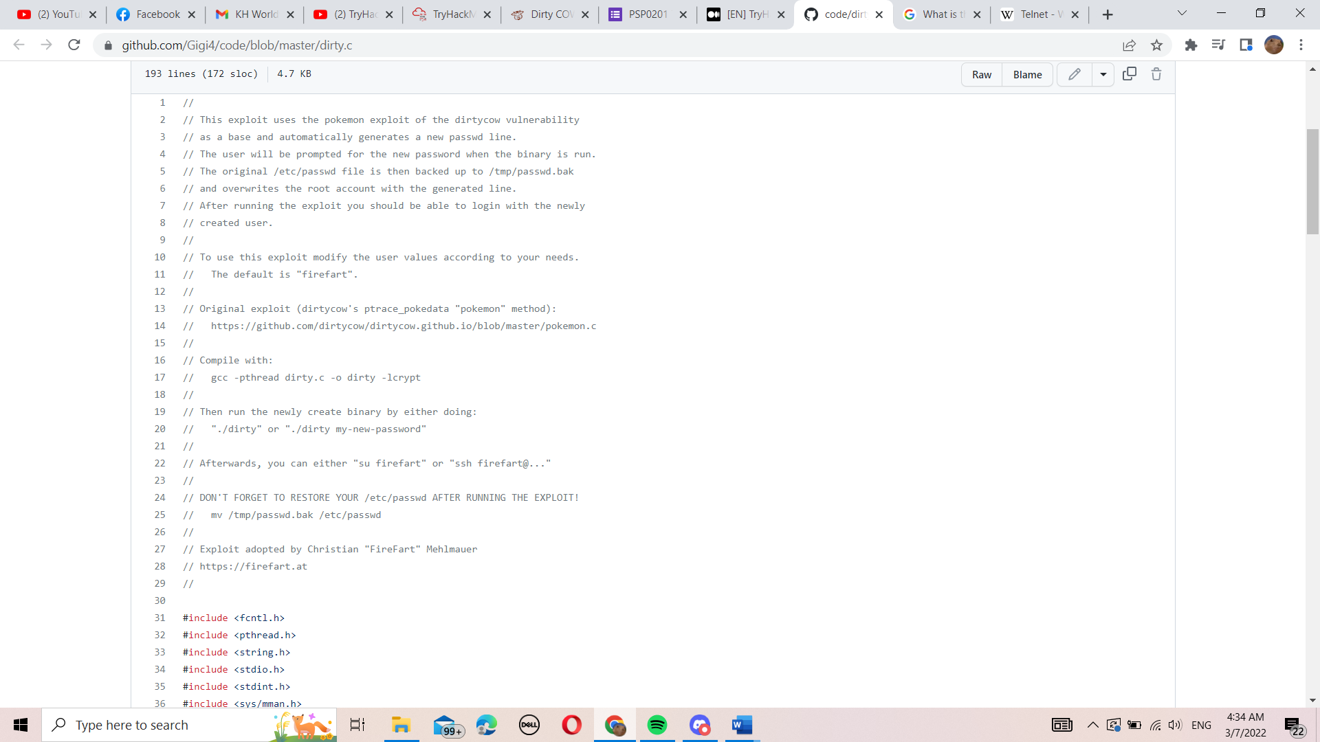

Question 6

Run the commands to compile the exploit, and run it.

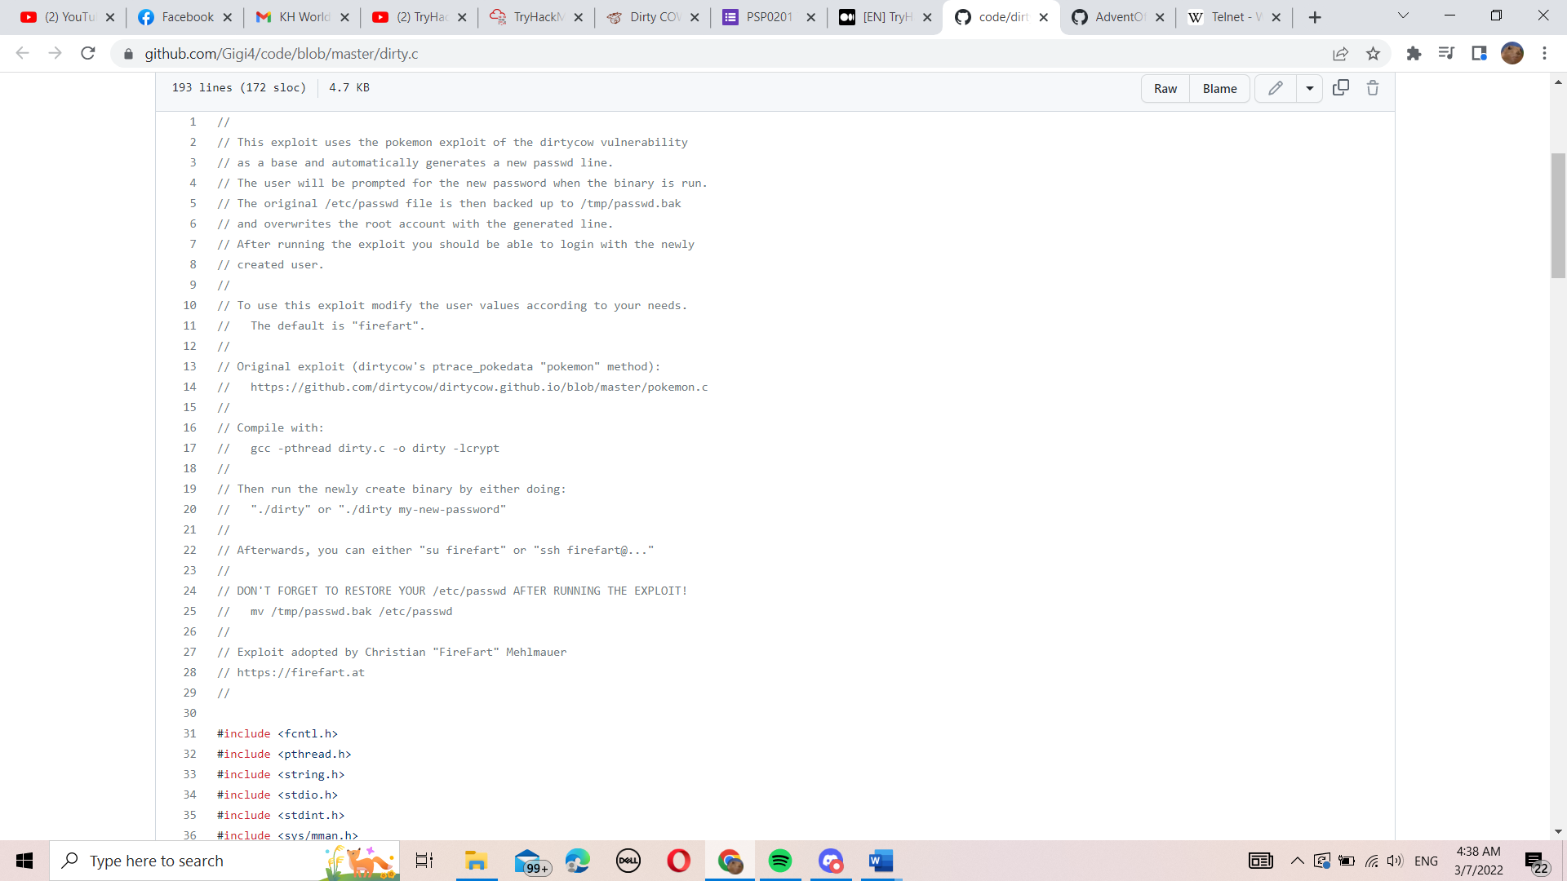

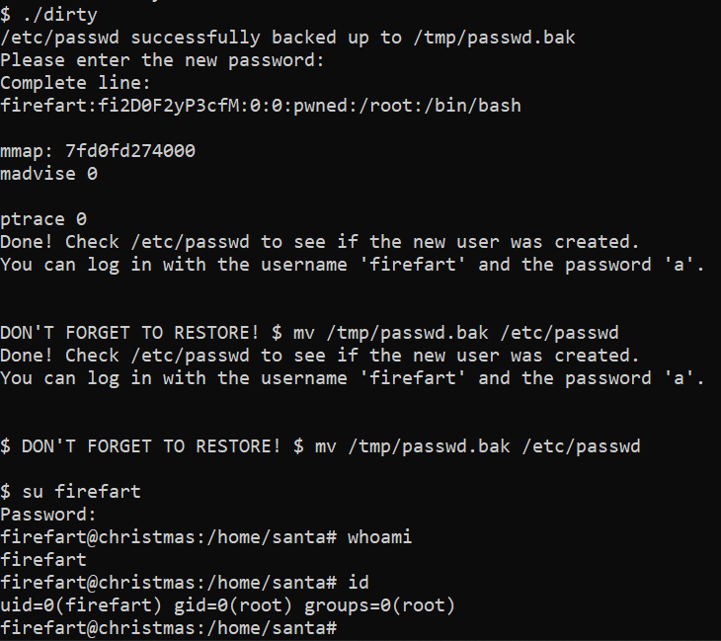

Question 7

After leaving behind the coal, you can run tree | md5sum

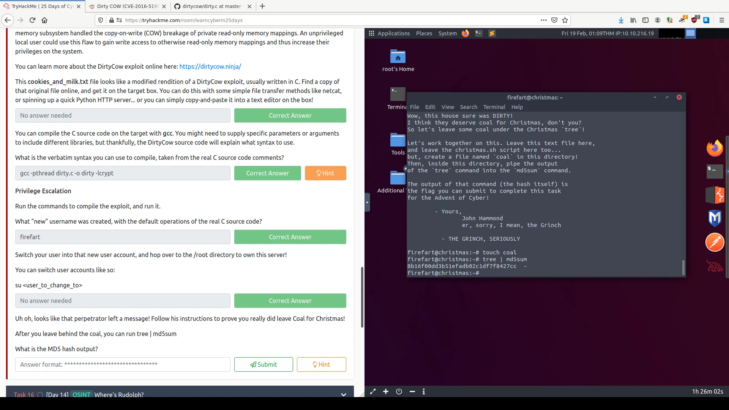

Question 8

We could find out that the CVE of Dirty Cows

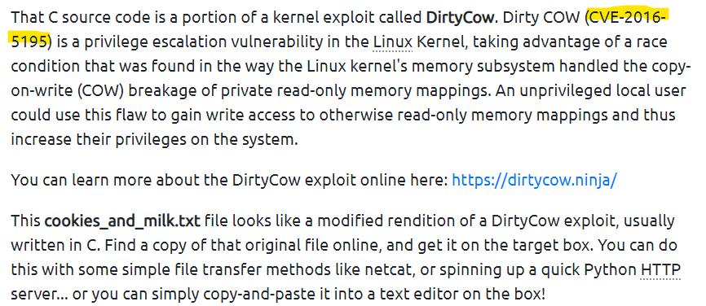

**Thought Process/Methodology:**

Firstly, you can use **nmap** with syntax like so. You will find out ssh,telnet,rpcbind. One of the known for the vulnerability and the old deprecated protocol is [telnet](https://en.wikipedia.org/wiki/Telnet). Telnet was developed in 1969 and it provided access to a [command-line interface](https://en.wikipedia.org/wiki/Command-line_interface) on a remote host. Besides,Log in and take a look around, enumerate a bit. Try login into the machine using telnet 10.10.185.12 on port 23. Commanding cat /etc/*release and it will show the distribution of Linux and version number. Log in with the username and password given just now and do this with the cat command.Look through with the Github and we can find out that the real C source code comments that we can use to compile verbatim syntax. Run the commands to compile the exploit, and run it. After you leave behind the coal, you can run tree | md5sum.

**Day 14: OSINT - Where's Rudolph?**

**Tools used**: Tryhackme website, Twitter, Reddit, Google Map, EXIF Data

**Solution/walkthrough**:

Question 1

The URL <https://www.reddit.com/user/IGuidetheClaus2020/comments/> will directly to Rudolph's Reddit comment history.

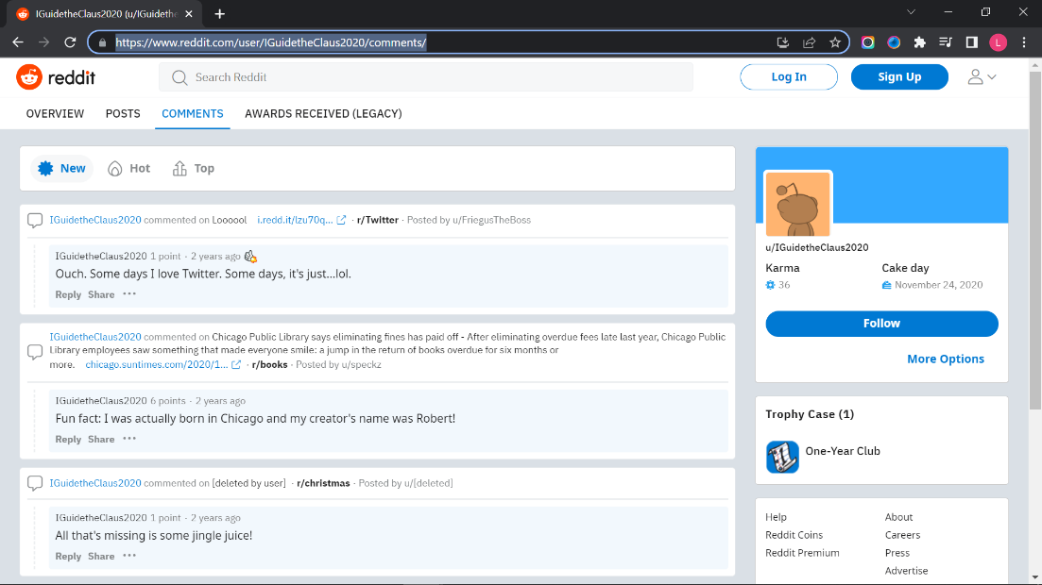

Question 2

According the Reddit comment history, he was born in Chicago.

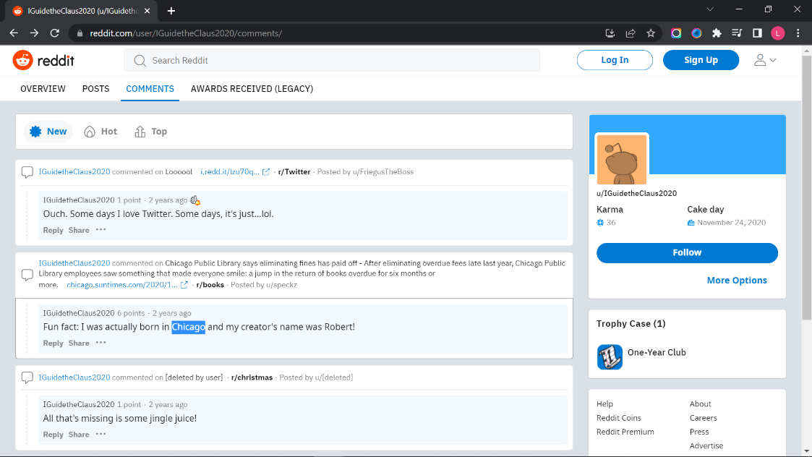

Question 3

The Robert’s last name is May.

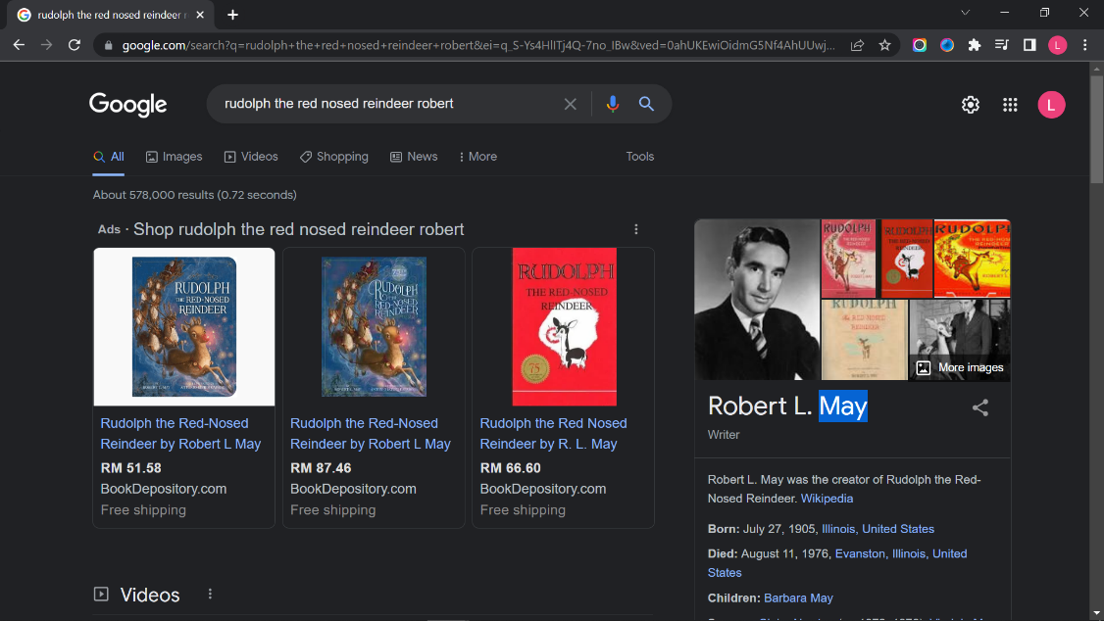

Question 4

Rudolph have an account in Twitter.

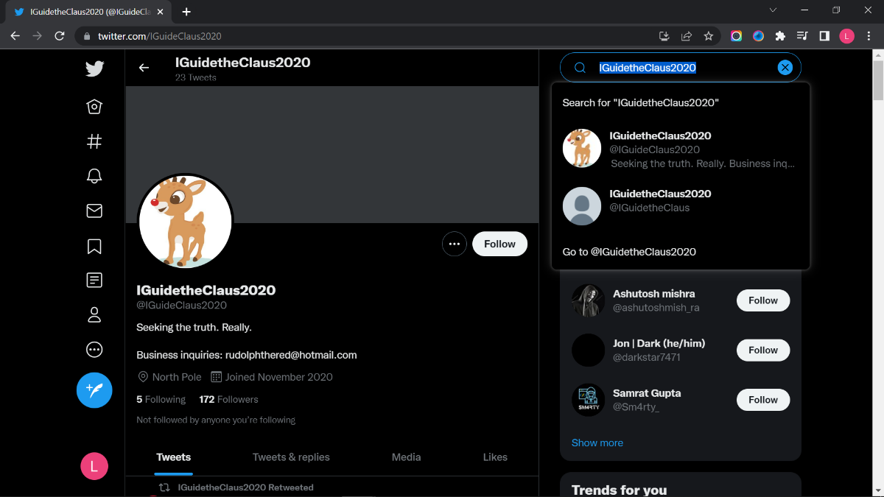

Question 5

Rudolph's username on that platform is IGuideClaus2020.

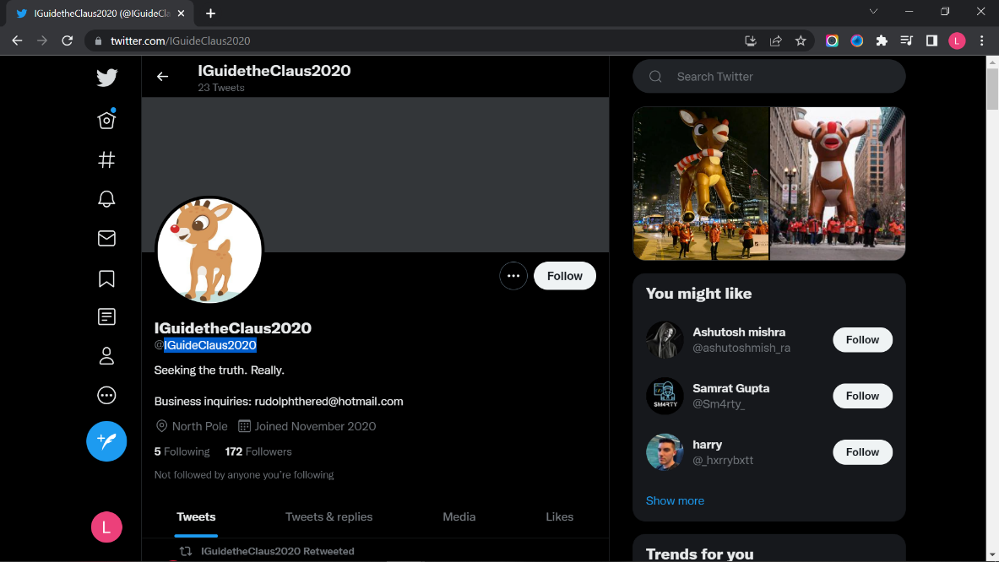

Question 6

Rudolph's favorite TV show is Bachelorette.

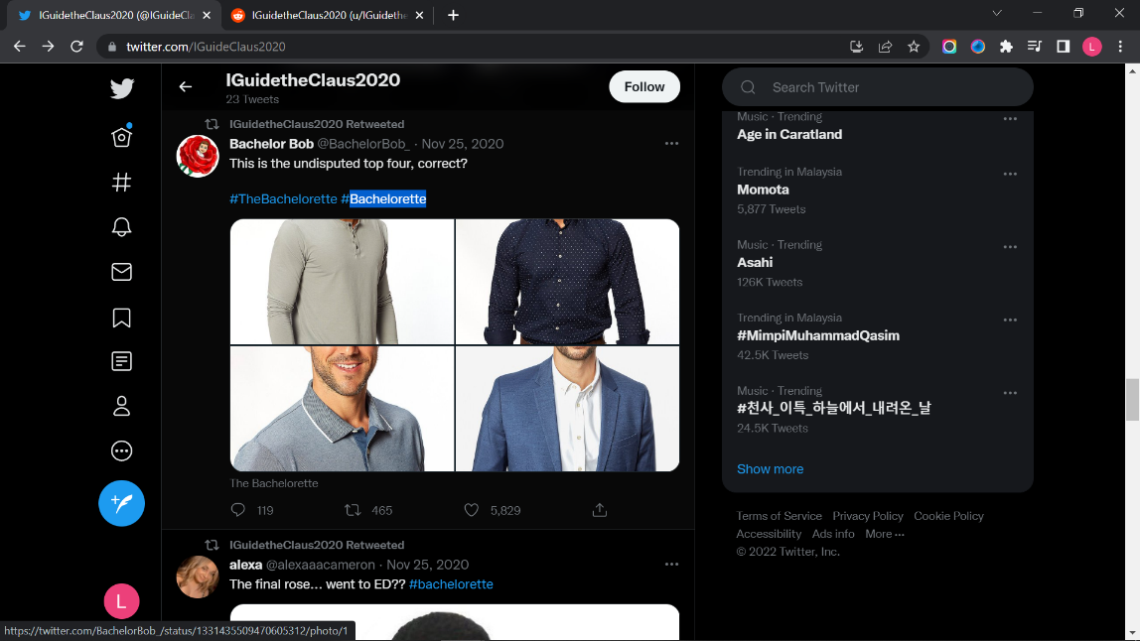

Question 7

The parade takes place in Chicago.

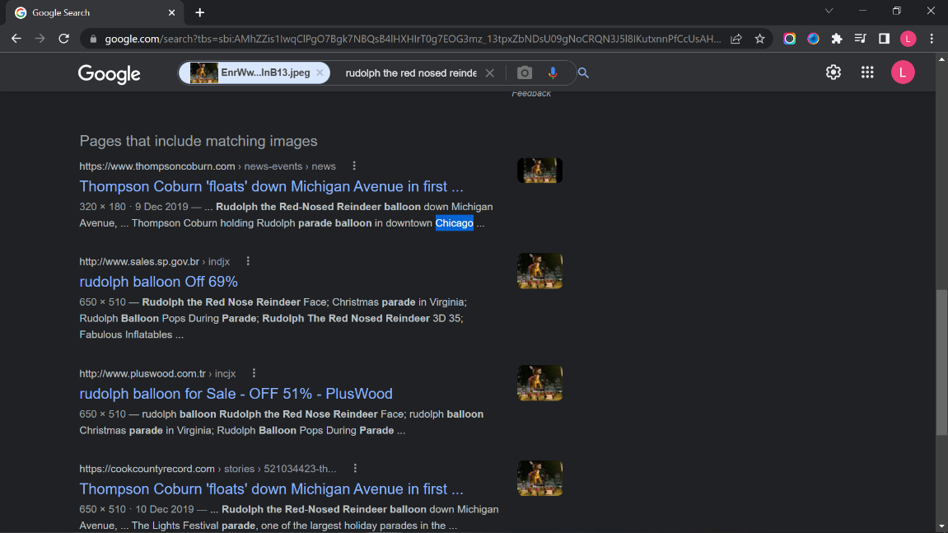

Question 8

Use the photo metadata viewer tool “EXIF Data” to find the specific coordinate.

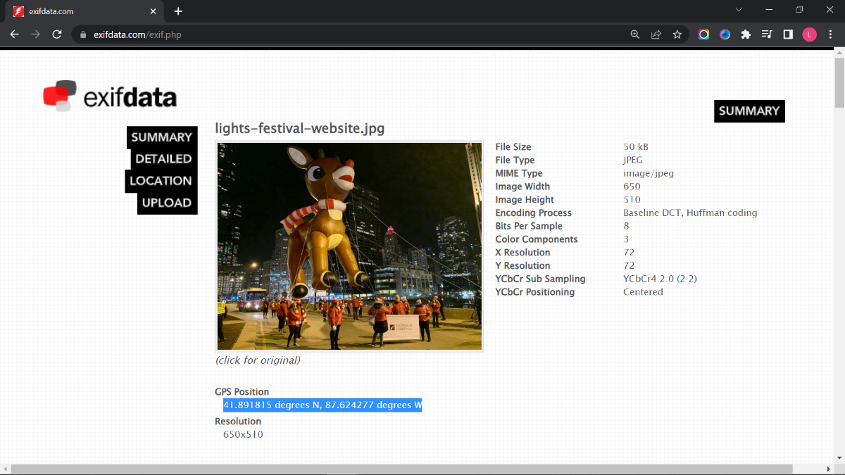

Question 9

The flag can be found in “EXIF Data”.

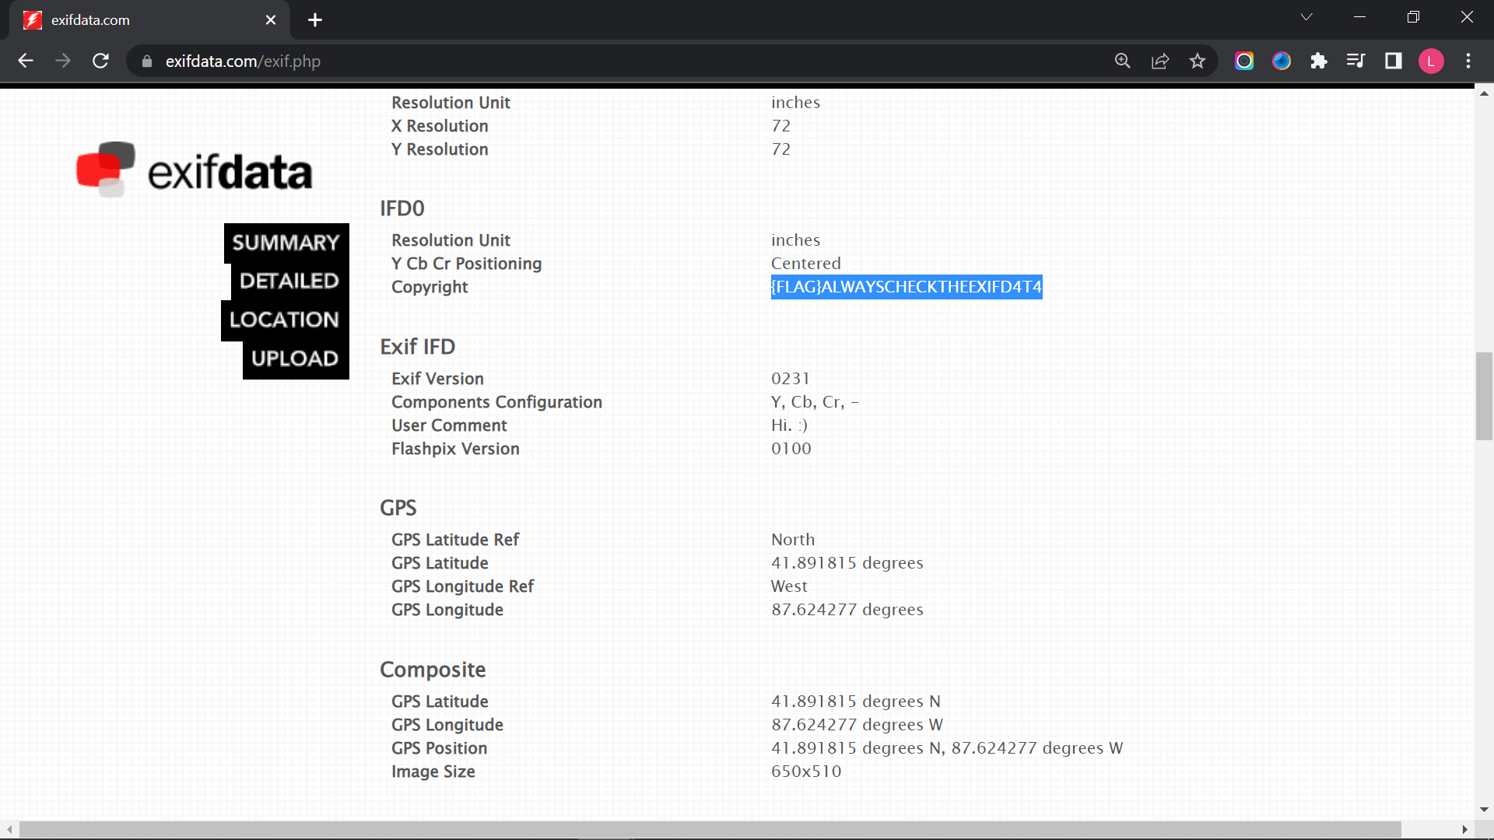

Question 11

Type the specific coordinate in google map and find the street numbers of the hotel address which is 540.

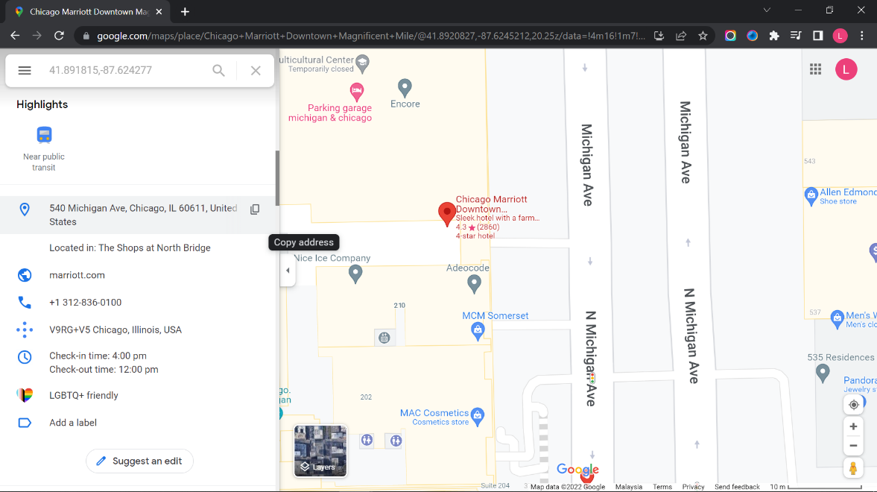

**Thought Process/Methodology:**

First, we type the URL <https://www.reddit.com/user/IGuidetheClaus2020/comments/> and enter into Rudolph’s Reddit. Next, we can know that Rudolph was born in Chicago through the Reddit post. We can google “Rudolph the red nosed reindeer Robert” to know the last name of Rudolph. We can go to Twitter and search “iguidetheclaus2020” to find the other social media platform on that Rudolph has an account. Rudolph’s username can be found on Twitter. Due to the Twitter post, we can know that the parade takes place in Chicago. Then, we can save as the photo in the post and use the photo metadata viewer tool “EXIF Data” to find the specific coordinate of the photo taken. We can also find the flag in “EXIF Data”. We type the specific coordinate in Google Map to find the street numbers of the hotel address.

**Day 15: Scripting - There's a Python in my stocking!**

**Tools used**: Visual Studio Code, Command Prompt

**Solution/walkthrough**:

Question 1

The output of True + True is 2.

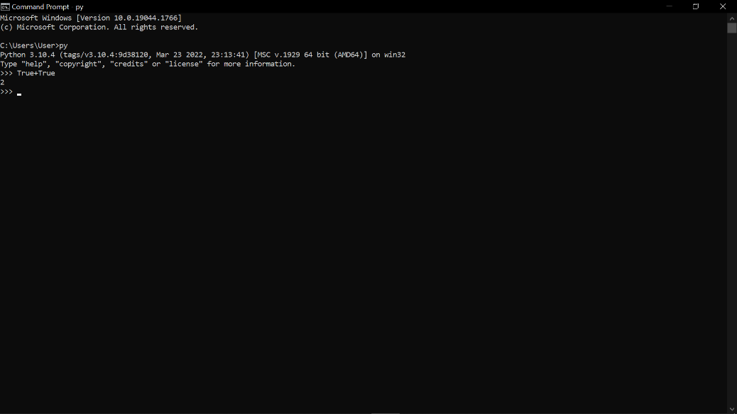

Question 2

The database for installing other peoples libraries called PyPi.

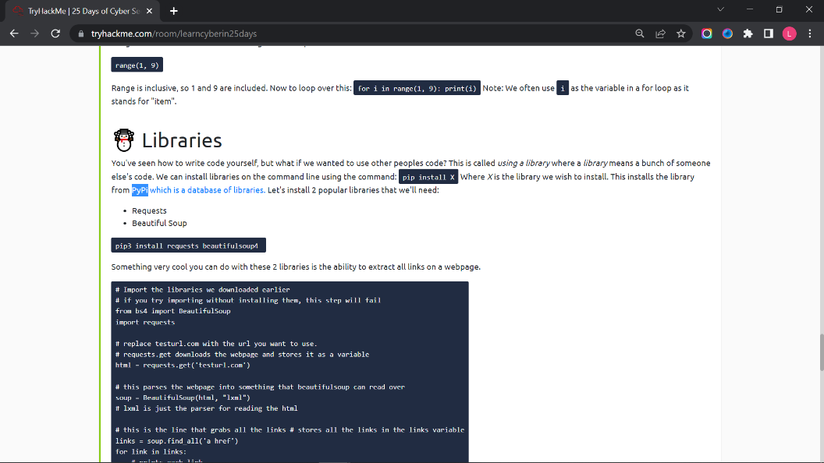

Question 3

The output of bool("False") is True.

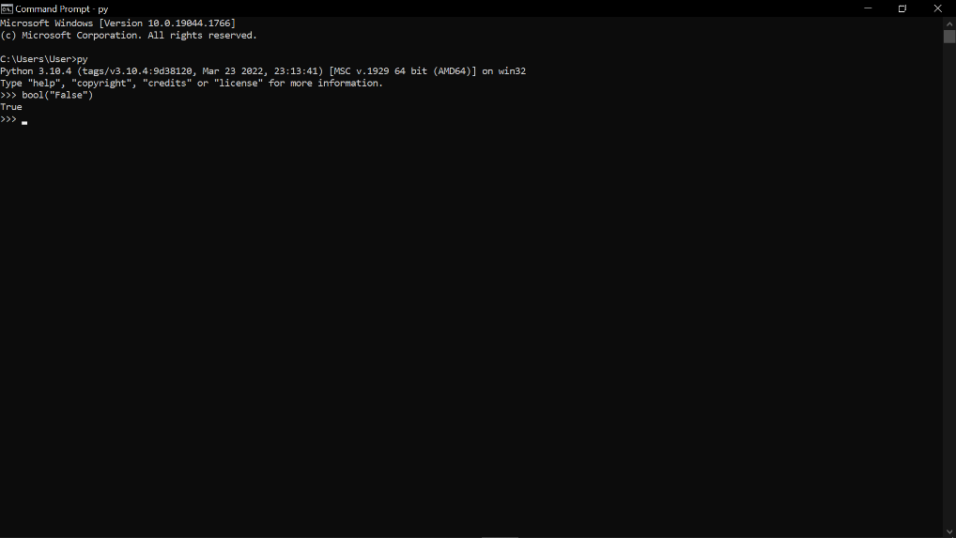

Question 4

The library lets us download the HTML of a webpage is Requests.

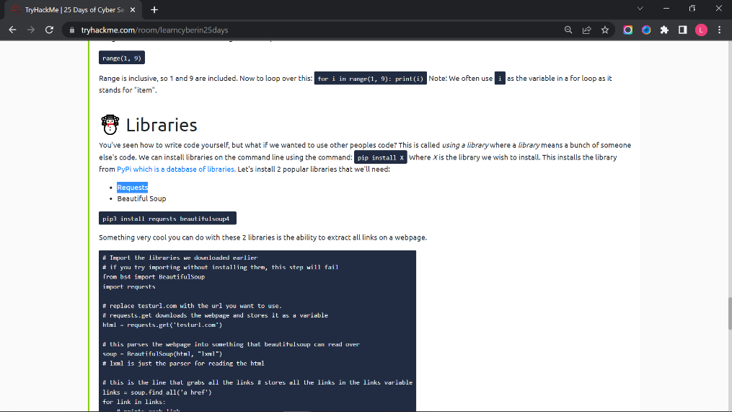

Question 5

The output of the program provided in "Code to analyse for Question 5" in today's material is [1, 2, 3, 6].

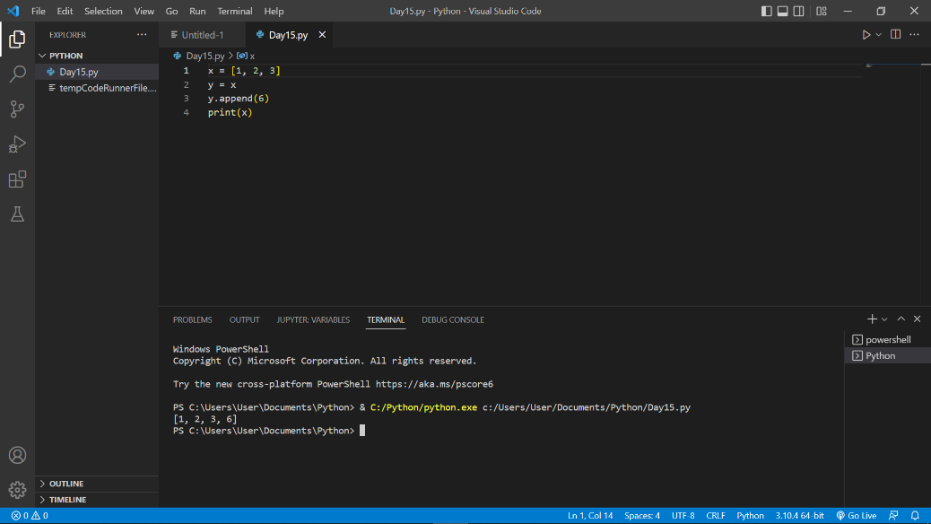

Question 6

Pass by reference causes the previous task to output that.

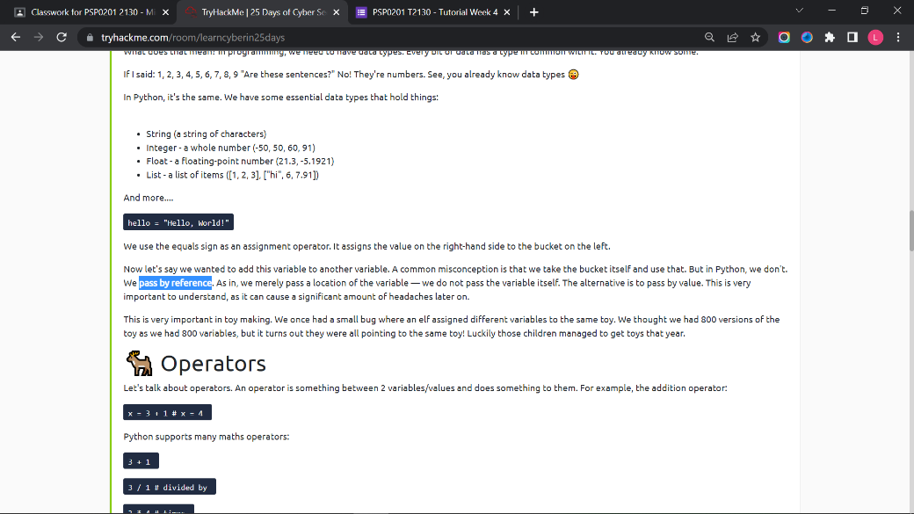

Question 7

The output will print “The Wise One has allowed you to come in.”

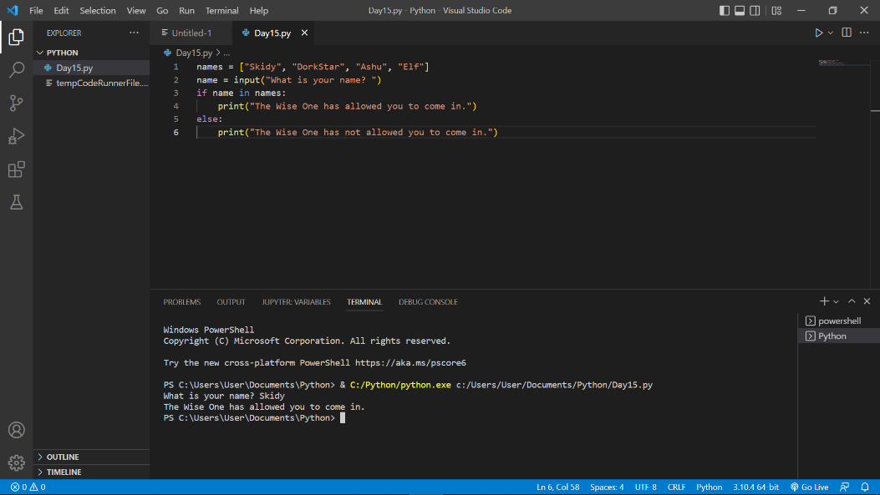

Question 8

The output will print “The Wise One not has allowed you to come in.”

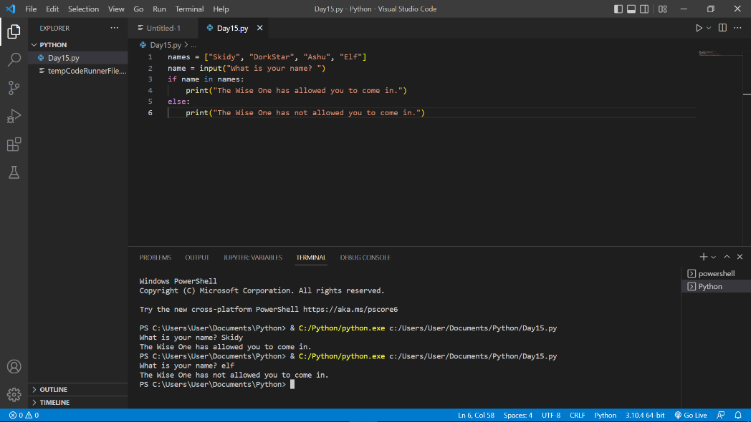

**Thought Process/Methodology:**

First, we type “True + True” in the command prompt and get the output of 2. We type bool("False") in the command prompt and get the output of True. For question 5, we type the code in the Visual Studio Code with the installed python extension and get the output of x which is [1, 2, 3, 6]. Next, we type the code in the Visual Studio Code and run the code. For question 7, we can type the name “Skidy” and get the output of “The Wise One has allowed you to come in”. For question 8, we use the same code and type the name “elf”. We will get the output of “The Wise One not has allowed you to come in”.